Test on meteorological observation (English)

Notes
1. Wait for instructions before answering
2. You have 16 minutes for answering
3. You may use your calculator.

Introduction (in common with the test on renewable energy)
A solar panel converts solar energy to electrical power by absorbing solar radiation. A wind turbine also converts solar energy to electrical power, because the source of wind’s kinetic energy is solar energy. As explained in the figure, part of solar radiation from the sun is reflected back toward the space. The rest is absorbed by the atmosphere or the surface of the earth and then converted to thermal energy. The thermal energy finally escapes to the space in a form of infrared radiation. In the test on meteorological observation, those values are measured. In the test on renewable energy, efficiency of energy conversion of a solar panel and wind turbine is calculated.

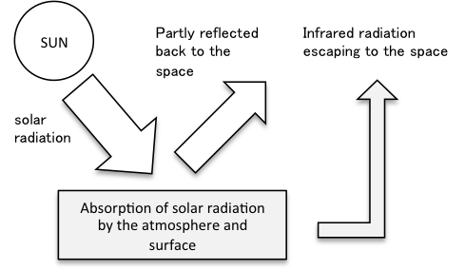

Question 0. Input values you observed.

0-1. Downward solar radiation from the sky observed at Point A over asphalt (W/m²)
0-2. Upward solar radiation reflected by the ground at Point A in W/m²
0-3. Downward solar radiation from the sky observed at Point B over grass (W/m²)
0-4. Upward solar radiation reflected by the ground at Point B (W/m²)
0-5. Temperature at the ground at Point A (degree Celsius)
0-6. Temperature at the ground at Point B (degree Celsius)

Question 1.
The ratio of reflected radiation at a particular surface is called albedo.
1-1. Calculate the albedo of the asphalt at Point A.
1-2. Calculate the albedo of the grass at Point B.
1-3 Choose the answer which is least likely to explain the difference between the measurements at Points A and B.

a. Color of the surface
b. Hardness of the ground
c. Roughness of the surface
d. Wetness of the surface

Question 2.
2-1. Calculate infrared energy emitted by the asphalt at Point A by assuming that the asphalt is a black body. The infrared energy may be obtained by following the Stefan- Boltzmann law.
σ(273.15 + t)⁴
Here, σ is 5.67 ×10⁻⁸ (W/m² K⁻⁴), and t is temperature in degree Celsius. The answer should be rounded off to the first decimal place. The unit is W/m².

2-2 Calculate infrared energy emitted by the grass at Point B.

2-3 Choose the answer which is least likely to explain the difference in the measurements of infrared radiation at Points A and B.

a. Color of the surface
b. Wetness of the surface
c. Transpiration from the grass
d. Density of oxygen near the surface produced by the grass

