Name: _____________________________________ Country: ____________
Practical 02

Material: Psychrometer
1) Measure the air (dry and wet) temperatures in two places: under the sun and in the shadow. Try to choose places with the same land-use type.
- temperature in sunny place dry: ___________ wet:___________
- temperature in shaded place dry: ___________ wet:___________
2) Where should the relative humidity be higher? (5 points)
- In the sunny place
- In the shaded place
- Similar in both places.
3) Using the given table, what is the relative humidity (percentage) in both sites?
- relative humidity in the sunny place: ___________ (%) (2 points)
- relative humidity in the shaded place: __________ (%) (2 points)

Table to estimate relative humidity (%) using the wet bulb temperature (axis Y) and the difference between the dry and wet bulb temperatures (axis X).
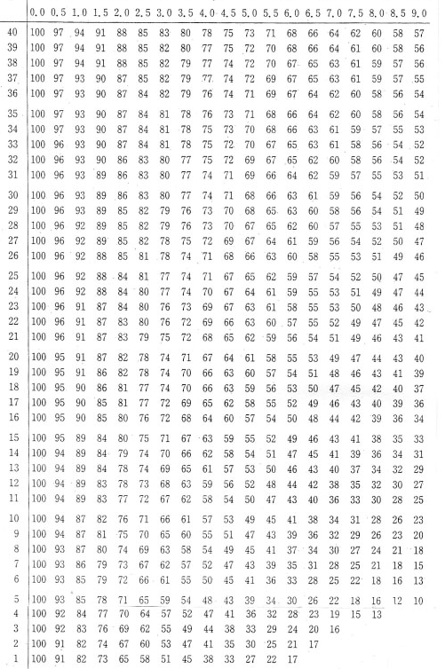
Dry bulb temperature minus wet bulb temperature
Wet bulb temperature (ºC)

